实验七 防火墙IPSec与VPN的配置
姓名：杨佳伲 学号：2022132006 班级：信安实验221班

实验目的
- 通过该实验掌握PIX防火墙IPSec与VPN的配置。

实验任务
- 配置PIX防火墙IPSec
- 配置PIX防火墙VPN
- 验证实验结果

三、实验设备
- PIX防火墙两台，CISCO 2950交换机两台，控制线一根，网络连接线若干，PC机若干，Sniffer软件一套。

四、实验拓扑图和设备接口
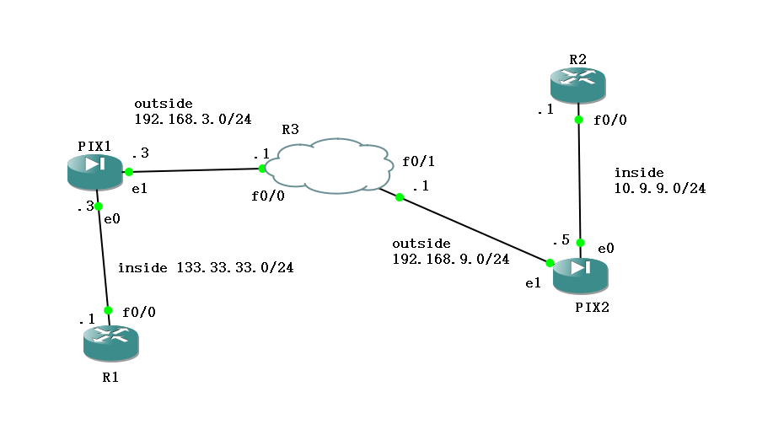
图 1 试验拓扑图
表 1 防火墙 PIX
 | interface | Type | nameif | Security level | IP Address
1 | E0 | physicallogical | inside | 100 | 10.9.9.5
2 | E1 | physicallogical | outside | 0 | 192.168.9.5

表 2 outside-R1-C3700
 | interface | IP Address
1 | F 0/0 | 133.33.33.1

表 3 inside-R2-C3700
 | interface | IP Address
1 | F 0/0 | 10.9.9.1

表 4 R3-C3700
 | interface | IP Address
1 | F 0/0 | 192.168.3.1
2 | F 0/1 | 192.168.9.1

表 1 路由器 R1/2/3 配置步骤(步骤类似只是ip和route有差别)
R1
步骤 1 | 配置接口 f0/0  R1(config)#int f 0/0  R1(config-if)#ip add 133.33.33.1 255.255.255.0  R1(config-if)#no sh
步骤 2 | 配置路由（R1/2）  R1(config)#ip route 0.0.0.0 0.0.0.0 133.33.33.3  R1(config)#ip route 0.0.0.0 0.0.0.0 10.9.9.5  R1(config)#end  R1#wr
步骤 3 | 配置telnet连接无密码（R1/2/3）  R1(config)#line vty 0 4  R1(config-line)#no login
表 2 防火墙 pix2 配置步骤
Pix2
步骤 1 | pixfirewall> en  Password:  pixfirewall# conf t  pixfirewall(config)# int e0  pixfirewall(config-if)# ip add 10.9.9.5 255.255.255.0  pixfirewall(config-if)# no sh  pixfirewall(config-if)# nameif in  pixfirewall(config-if)# nameif ins  pixfirewall(config-if)# nameif inside  INFO: Security level for "inside" set to 100 by default.  pixfirewall(config-if)# no sh  pixfirewall(config-if)# exit  pixfirewall(config)# int e1  pixfirewall(config-if)# ip add 192.168.9.5  pixfirewall(config-if)# ip add 192.168.9.5 255.255.255.0  pixfirewall(config-if)# nam  pixfirewall(config-if)# nameif outside  INFO: Security level for "outside" set to 0 by default.  pixfirewall(config-if)# no sh  pixfirewall(config-if)# end  pixfirewall# show ip  System IP Addresses:  Interface Name IP address Subnet mask Method  Ethernet0 inside 10.9.9.5 255.255.255.0 manual  Ethernet1 outside 192.168.9.5 255.255.255.0 manual  Current IP Addresses:  Interface Name IP address Subnet mask Method  Ethernet0 inside 10.9.9.5 255.255.255.0 manual  Ethernet1 outside 192.168.9.5 255.255.255.0 manual  pixfirewall# show int ip br  Interface IP-Address OK? Method Status Protocol  Ethernet0 10.9.9.5 YES manual up up  Ethernet1 192.168.9.5 YES manual up up  Ethernet2 unassigned YES unset administratively down up  Ethernet3 unassigned YES unset administratively down up  Ethernet4 unassigned YES unset administratively down up  pixfirewall# wr  pixfirewall# conf t  pixfirewall(config)# route outside 0.0.0.0 0.0.0.0 192.168.9.1  pixfirewall(config)#
步骤 2 | pixfirewall# conf t  pixfirewall(config)# access-list 101 permit ip 10.9.9.0 255.255.255.0 133.33.33.0 255.255.255.0  pixfirewall(config)# access-list aclvpn permit tcp host 133.33.33.1 host 10.9.9.1  pixfirewall(config)# access-list aclvpn permit icmp any any  pixfirewall(config)# access-group aclvpn in interface outside  pixfirewall(config)# nat (inside) 0 access-list 101  pixfirewall(config)# isakmp policy 10  The DES algorithm requires a VPN-DES activation key.  pixfirewall(config)# activation-key 0x6f91ddb5 0x3c8ce153 0xcb588bee 0x234c4f77
步骤 3 | pixfirewall# conf t  pixfirewall(config)# isakmp policy 10  pixfirewall(config-isakmp-policy)# group 1  pixfirewall(config-isakmp-policy)# lifetime 86400  pixfirewall(config-isakmp-policy)# encryption des  pixfirewall(config-isakmp-policy)# authentication pre-share  pixfirewall(config-isakmp-policy)# hash sha  pixfirewall(config-isakmp-policy)# exit  pixfirewall(config)# isakmp enable outside  pixfirewall(config)# isakmp key cuit123 address 192.168.3.3  pixfirewall(config)# crypto map fw1 10 match address 101  pixfirewall(config)# crypto map fw1 10 set peer 192.168.3.3  pixfirewall(config)# crypto ipsec transform-set fw5 esp-3des  pixfirewall(config)# crypto map fw1 10 set transform-set fw5  pixfirewall(config)# crypto map fw1 10 ipsec-isakmp  pixfirewall(config)# crypto map fw1 interface outside  pixfirewall(config)# no sysopt connection permit-vpn  pixfirewall(config)# show run crypto

表 3 防火墙pix1配置步骤
PIX1
步骤 1 | pixfirewall> en  Password:  pixfirewall# conf t  pixfirewall(config)# int e0  pixfirewall(config-if)# ip add 133.33.33.3 255.255.255.0  pixfirewall(config-if)# no sh  pixfirewall(config-if)# nameif inside  INFO: Security level for "inside" set to 100 by default.  pixfirewall(config-if)# exit  pixfirewall(config)# int e1  pixfirewall(config-if)# ip add 192.168.3.3 255.255.255.0  pixfirewall(config-if)# no sh  pixfirewall(config-if)# nameif outside  INFO: Security level for "outside" set to 0 by default.  pixfirewall(config-if)# end  pixfirewall# show ip  System IP Addresses:  Interface Name IP address Subnet mask Method  Ethernet0 inside 133.33.33.3 255.255.255.0 manual  Ethernet1 outside 192.168.3.3 255.255.255.0 manual  Current IP Addresses:  Interface Name IP address Subnet mask Method  Ethernet0 inside 133.33.33.3 255.255.255.0 manual  Ethernet1 outside 192.168.3.3 255.255.255.0 manual  pixfirewall# wr  pixfirewall# conf t  pixfirewall(config)# route outside 0.0.0.0 0.0.0.0 192.168.3.1
步骤 2 | pixfirewall# conf t  pixfirewall(config)# access-list 101 permit ip 133.33.33.0 255.255.255.0 10.9$  pixfirewall(config)# access-list aclvpn permit tcp host 10.9.9.1 host 133.33.$  pixfirewall(config)# access-list aclvpn permit icmp any any  pixfirewall(config)# access-group aclvpn in interface outside  pixfirewall(config)# nat (inside) 0 access-list 101  pixfirewall(config)# isakmp policy 10  The DES algorithm requires a VPN-DES activation key.  pixfirewall(config)# activation-key 0x6f91ddb5 0x3c8ce153 0xcb588bee 0x234c4f77
步骤 3 | pixfirewall# conf t  pixfirewall(config)# isakmp policy 10  pixfirewall(config-isakmp-policy)# group 1  pixfirewall(config-isakmp-policy)# lifetime 86400  pixfirewall(config-isakmp-policy)# encryption des  pixfirewall(config-isakmp-policy)# authentication pre-share  pixfirewall(config-isakmp-policy)# hash sha  pixfirewall(config-isakmp-policy)# exit  pixfirewall(config)# isakmp enable outside
pixfirewall(config)# isakmp key cuit123 address 192.168.9.5
pixfirewall(config)# show run isakmp
crypto isakmp enable outside
crypto isakmp policy 10
authentication pre-share
encryption des
hash sha
group 1
lifetime 86400
no crypto isakmp nat-traversal
pixfirewall(config)# crypto map fw1 10 match address 101
pixfirewall(config)# crypto map fw1 10 set peer 192.168.9.5
pixfirewall(config)# crypto ipsec transform-set fw5 esp-3des
pixfirewall(config)# crypto map fw1 10 set transform-set fw5
pixfirewall(config)# crypto map fw1 10 ipsec-isakmp
pixfirewall(config)# crypto map fw1 interface outside
pixfirewall(config)# no sysopt connection permit-vpn
pixfirewall(config)# show run crypto
crypto ipsec transform-set fw5 esp-3des esp-none
crypto map fw1 10 match address 101
crypto map fw1 10 set peer 192.168.9.5
crypto map fw1 10 set transform-set fw5
crypto map fw1 interface outside
crypto isakmp enable outside
crypto isakmp policy 10
authentication pre-share
encryption des
hash sha
group 1
lifetime 86400
no crypto isakmp nat-traversal

pixfirewall(config)# show run access-group
access-group aclvpn in interface outside
pixfirewall(config)# show access-list
access-list cached ACL log flows: total 0, denied 0 (deny-flow-max 4096)
alert-interval 300
access-list 101; 1 elements
access-list 101 line 1 extended permit ip 133.33.33.0 255.255.255.0 10.9.9.0 255.255.255.0 (hitcnt=0) 0x8bb037 30
access-list aclvpn; 2 elements
access-list aclvpn line 1 extended permit tcp host 10.9.9.1 host 133.33.33.1 eq telnet (hitcnt=0) 0x41d3b41f
access-list aclvpn line 2 extended permit icmp any any (hitcnt=0) 0x6dbf3124
pixfirewall(config)# show crypto ipsec sa

在防火墙上的VPN配置：
（1）配置IKE（ISAKMP）策略
（2）IKE phase1：定义IKE Phase One中的一些策略
（3）定义认证标识（Pre-Shared）
定义认证密码（或者证书）
（4）IKE phase 2：配置IPsec transform
（5）定义感兴趣流量
（6）创建crypto map
（7）将crypto map应用于接口
Show命令验证VPN
注：在配Ipsec的策略时无法配置，原因是show version 后发现VPN-DES等项为Disable，所以无法配置，解决办法是在在防火墙上运行activeation-key命令。

实验步骤
5.1：我的实验拓扑图
5.2：R1 的配置 --- IP，静态路由：
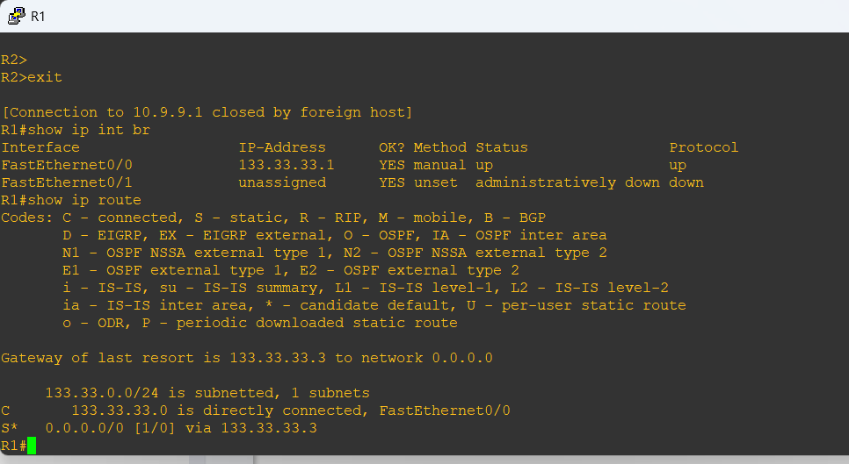
5.3：R2 的配置 --- IP，静态路由：
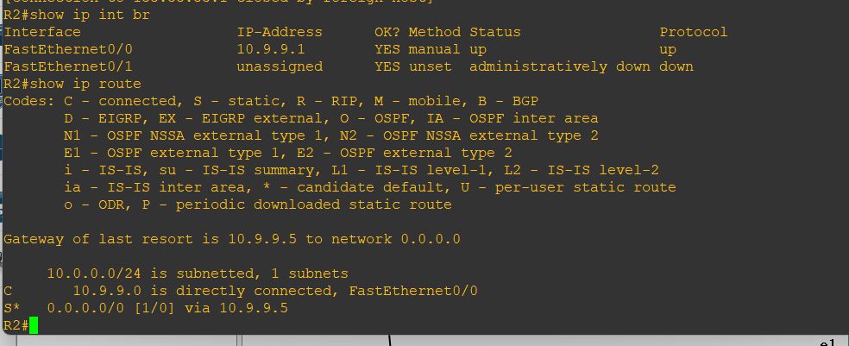
5.4：PIX1/2虚拟防火墙 – IP,安全级别，静态路由
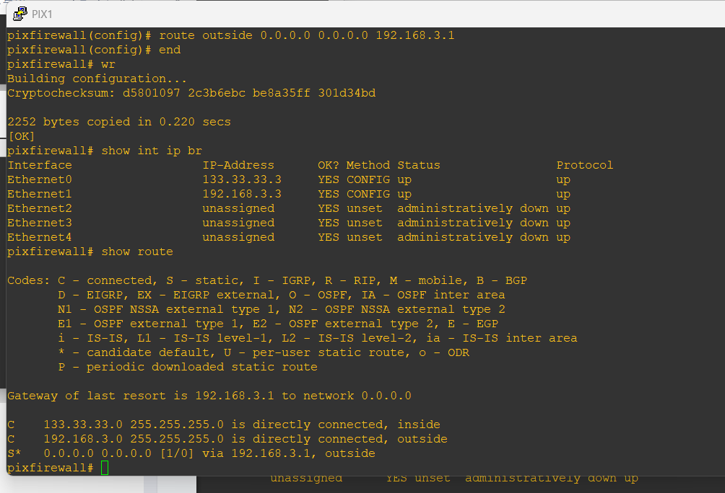
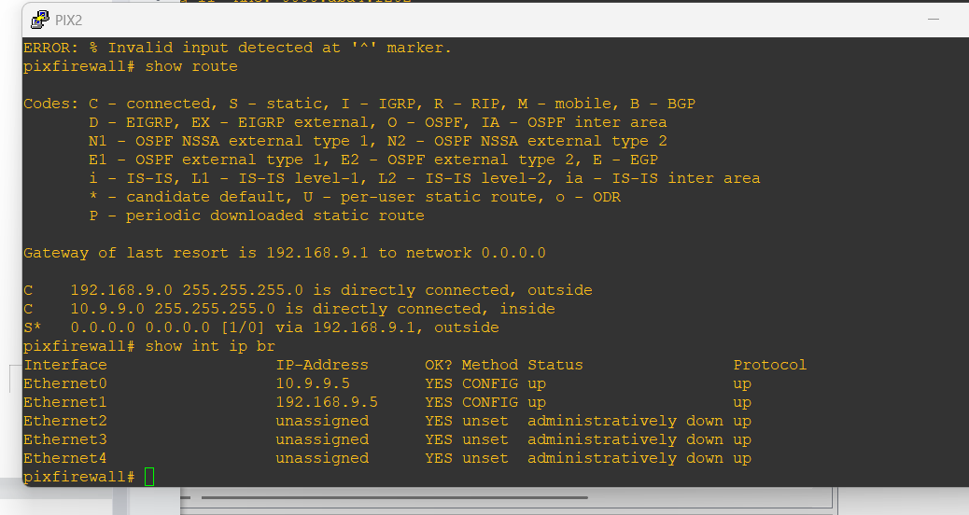
5.5：配置ACL对ipsec数据进行封装
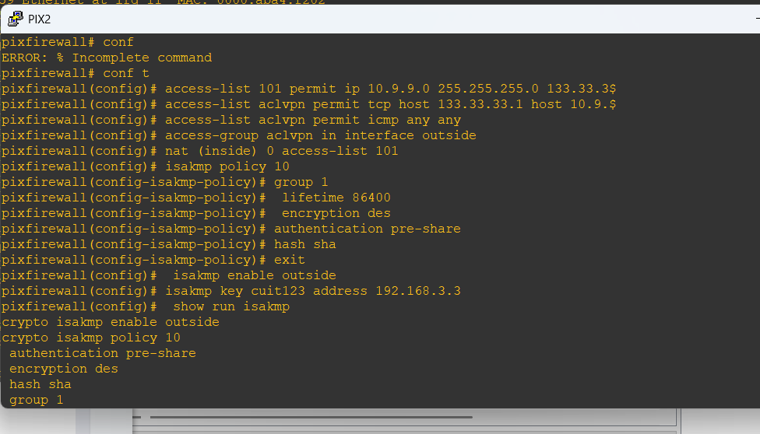

实验结果

6.1 【 R1pingR2，R1telnetR2】
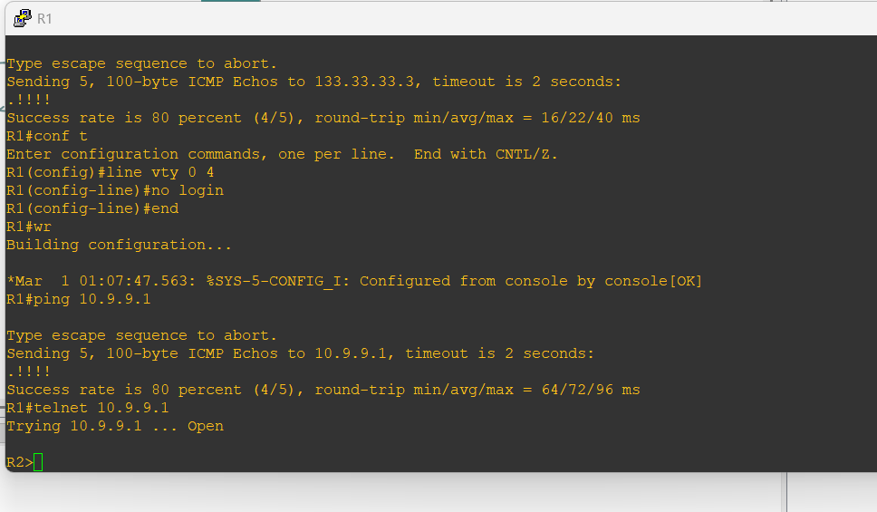

6.2 【R2pingR1，R2telnetR1】
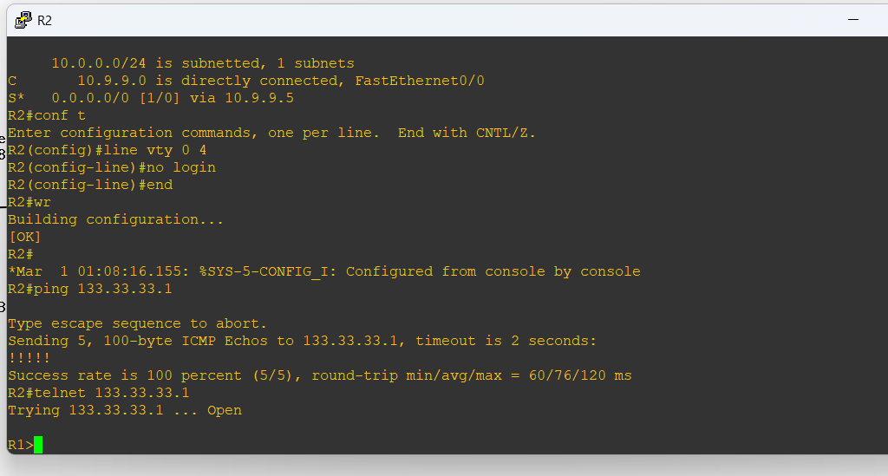

七、实验总结
本次实验主要围绕PIX防火墙的IPSec和VPN配置展开，通过实际操作掌握了网络安全设备的基本配置方法，并验证了配置结果的正确性.我深入理解了IPSec VPN的工作原理和配置流程，掌握了PIX防火墙的基本操作命令。实验过程中遇到的配置问题也锻炼了我的故障排查能力。

